Top Technologies Used by India App Developers for Logistics Apps

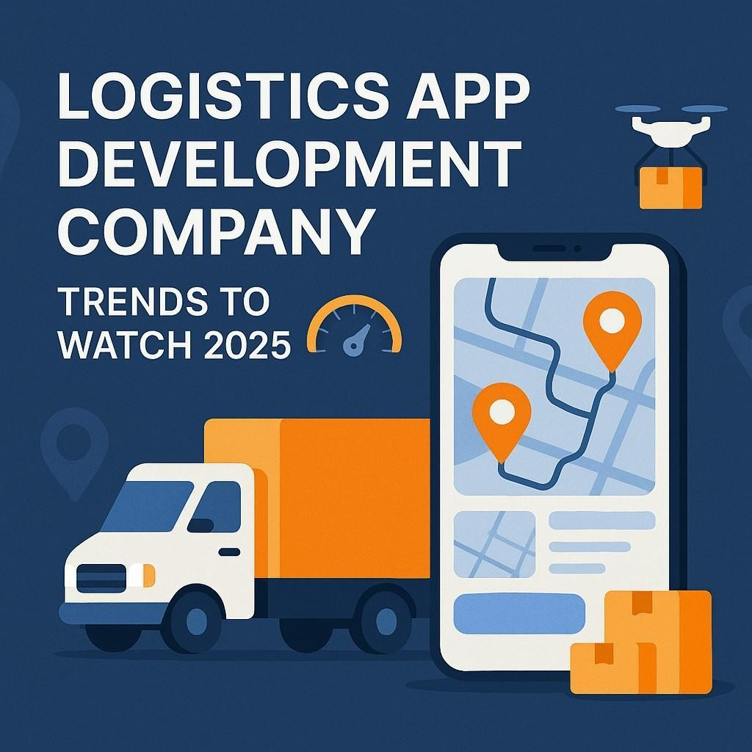

India has rapidly become a global hub for app development, with logistics being one of the most sought-after domains in recent years. As the logistics industry embraces digital transformation, the demand for robust, scalable, and innovative logistics apps continues to rise. Behind the

scenes, a [*logistics app development company*](https://indiaappdeveloper.com/transport-logistics-app-development/)in India leverages cutting-edge technologies to meet evolving market needs.

From real-time tracking to predictive analytics, logistics apps are becoming more intelligent and efficient. In this blog, we’ll explore the **top technologies** used by **app developers in India** for logistics apps and how these innovations are shaping the future of supply chain management.

# Internet of Things (IoT)

IoT is revolutionizing logistics by enabling real-time monitoring of goods, vehicles, and warehouse environments. Indian app developers use IoT to connect devices such as GPS trackers, RFID tags, and sensors that feed data into mobile apps.

## Key Benefits:

* + Real-time location tracking of shipments
  + Monitoring temperature-sensitive goods
  + Optimized route and vehicle management

Indian logistics app development companies often integrate IoT using platforms like AWS IoT, Azure IoT Hub, or custom APIs, offering businesses better control and visibility over their supply chains.

# Artificial Intelligence and Machine Learning (AI/ML)

AI and ML are at the core of next-gen logistics apps. Indian developers incorporate these technologies to optimize operations such as inventory management, delivery scheduling, and customer support.

## Applications:

* + Predictive analytics for demand forecasting
  + Route optimization using traffic patterns
  + Chatbots for 24/7 customer service

AI-powered analytics can also reduce operational costs and enhance customer experience, making it a favorite among logistics app development companies.

# Cloud Computing

Cloud-based logistics apps provide scalability, data security, and remote access—essential features for businesses that operate across cities or even countries.

## Popular Cloud Platforms:

* + Amazon Web Services (AWS)
  + Google Cloud Platform (GCP)
  + Microsoft Azure

These platforms allow [**app developers in India**](https://indiaappdeveloper.com/)to deploy logistics apps with high uptime, secure backups, and multi-device synchronization, reducing infrastructure overhead and ensuring seamless performance.

# Blockchain Technology

Blockchain is emerging as a powerful tool for enhancing transparency and security in logistics. While still maturing, many Indian developers are exploring blockchain to build decentralized and tamper-proof systems for shipment tracking and contract management.

## Features:

* + Immutable transaction records
  + Smart contracts for automated processing
  + Fraud prevention in the supply chain

Blockchain-based apps are especially useful for international logistics and high-value shipments.

# Geolocation & GPS Integration

Geolocation is a must-have feature in logistics apps, and Indian developers are proficient in integrating accurate GPS tracking systems.

## Technologies Used:

* + Google Maps API
  + Mapbox
  + OpenStreetMap

Real-time vehicle tracking, estimated time of arrival (ETA), geofencing, and route planning are all powered by geolocation technologies, enabling logistics businesses to manage their fleets efficiently.

# Mobile App Development Frameworks

To ensure quick deployment and cross-platform compatibility, Indian logistics app development companies commonly use the following frameworks:

## Popular Frameworks:

* + **Flutter** (by Google): Allows one codebase for both Android and iOS.
  + **React Native** (by Facebook): Ideal for performance-heavy applications.
  + **Kotlin** and **Swift**: For native Android and iOS development, respectively.

These frameworks reduce [**app development cost in India**](https://indiaappdeveloper.com/detailed-guide-on-app-development-costs-in-india/), making logistics apps more affordable for startups and SMEs.

# Big Data and Analytics

Handling and interpreting large volumes of logistics data is crucial for decision-making. Indian developers often integrate big data technologies to process route data, fuel consumption, delivery times, and customer behavior.

## Tools Used:

* + Apache Hadoop
  + Apache Spark
  + Google BigQuery

These tools help businesses analyze patterns, reduce waste, and improve operational efficiency.

# Robotic Process Automation (RPA)

RPA automates routine tasks like order processing, billing, and reporting. App developers in India are increasingly embedding RPA tools into logistics apps to free up human resources and reduce errors.

## Examples:

* + Automating data entry from shipment documents
  + Sending automated delivery notifications
  + Invoice generation and reconciliation

By automating repetitive tasks, RPA significantly enhances productivity.

# Augmented Reality (AR)

Though still niche in logistics, AR is being explored for warehouse management and employee training. Indian developers are working with ARKit (Apple) and ARCore (Google) to create immersive AR-based warehouse navigation and inventory management systems.

# Why Choose Indian App Developers for Logistics Apps?

India has emerged as a global leader in mobile app development due to a combination of skilled professionals, cost-effective solutions, and innovative thinking.

## Key Advantages:

* + **Expertise**: Indian developers have hands-on experience with advanced technologies.
  + **Affordability**: The average *app development cost in India* is significantly lower compared to Western countries.
  + **Customization**: Indian logistics app development companies provide highly customized solutions tailored to specific business needs.
  + **Scalability**: Indian developers build apps that scale with your business growth.

# Conclusion

As logistics continues to evolve with technology, Indian app developers are playing a crucial role in shaping its future. From IoT to AI, and blockchain to big data, the range of technologies used in logistics app development is vast and sophisticated. Whether you're a startup looking to build a new logistics platform or an enterprise aiming to upgrade your supply chain management tools, partnering with a reputed *logistics app development company* in India can provide the right mix of innovation and cost-efficiency.

If you're exploring your options, consider evaluating **app development cost in India** and the vast talent pool available. The right technology stack, when combined with expert developers, can transform your logistics operations into a competitive advantage.